**Web Hosting with Port Forwarding**

A COURSE PROJECT REPORT

BY

**Mungara Ganesh Haricharan (RA1911030010091)**

Under the guidance of

**Dr.C.N.S.Vinoth Kumar**

*In partial fulfilment for the Course*

of

18CSC302J - COMPUTER NETWORKS

in

Department of Networking & Communications



**FACULTY OF ENGINEERING & TECHNOLOGY**

**SRM INSTITUTE OF SCIENCE AND TECHNOLOGY**

**Kattankulathur, Chengalpattu District**

**NOVEMBER 2021**

**SRM INSTITUTE OF SCIENCE AND TECHNOLOGY**

(Under Section 3 of UGC Act, 1956)

**BONAFIDE CERTIFICATE**

Certified that this project report **“Web Hosting with Port Forwarding”** is the bonafide work of  Mungara Ganesh Haricharan (RA1911030010091) who carried out the project work under my  supervision.

**SIGNATURE SIGNATURE**



**Dr.C.N.S.Vinoth Kumar**

**Assistant Professor,**

**CSE,**

**SRM Institute of Science and Technology,**

**Potheri, SRM Nagar, Kattankulathur**

**Tamil Nadu 603203**

**TABLE OF CONTENTS**

**No.kl Contents Page No.**

1 Abstract 4   
2 Introduction 5   
3 Requirement Analysis   
4 Architecture & Design   
5 Implementation   
6 Experiment Results & Analysis

6.1 Results

6.2 Result Analysis

6.3 Conclusion & Future Work

7 References

**ABSTRACT**

This project aims to implement the concept of port forwarding. Port forwarding allows remote computers to connect to a specific computer or service within a private LAN. Port forwarding is an application of NAT that redirects a communication request from one address and port number combination to another while the packets are traversing a network gateway. With port forwarding we can host a web app or a game lobby to the internet that usually runs on LAN. So, when a PC from the internet sends an HTTP request to the public IP of the server which runs the game or the web app, the request is forwarded to the private address of the server via the router and thus the PC’s will be able to communicate back and forth via WAN.

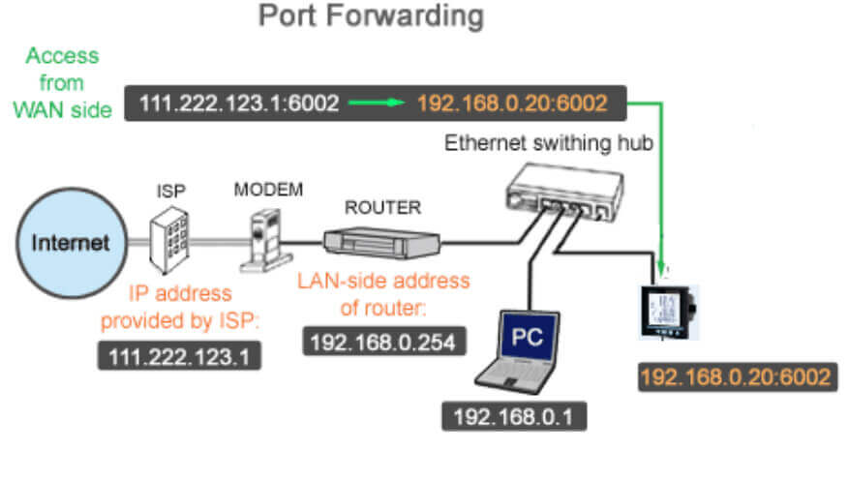

**INTRODUCTION**

Port forwarding is an application of network address translation (NAT) that redirects a communication request from one address and port number combination to another while the packets are traversing a network gateway, such as a router or firewall.

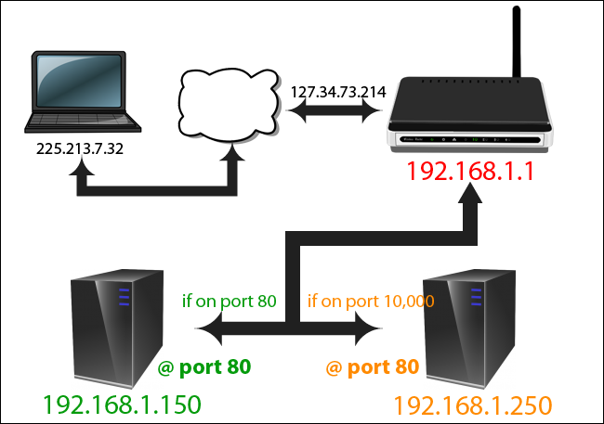

This project sets up port forwarding for a company. The company has a single public IP address assigned to it, for e.g., 210.1.1.1. The company has two websites in two servers. The two servers are connected to a single router with single IP address. One of the two servers is for admin and that is not accessible by the public. So, to make both the servers accessible via the single public IP, we implement *Port Forwarding.*

By implementing port forwarding, we can connect to admin server (website) by adding a port number at the end of the public IP address, for e.g., 210.1.1.1:5029. Using NAT, the router will forward this request to the private IP address of the server containing the admin files. If the IP address is entered without the port number, we will be redirected to the default main page because 210.1.1.1 is equal to 210.1.1.1:80.

This helps the employees to modify and work on files that are stored on the server directly from their home.

**REQUIREMENT ANALYSIS**

**Hardware Requirements**

* Cisco PT Servers – 2
* Home PC – 1
* 2960 Switch – 2
* 1841 Routers – 2
* Ethernet and Serial Cables

**Software Requirements**

* Platform – Cisco Packet Tracer
* Operating System – Any (Preferred – Windows 10)
* Basic Web Browser
* Router CLI

**ARCHITECTURE & DESIGN**

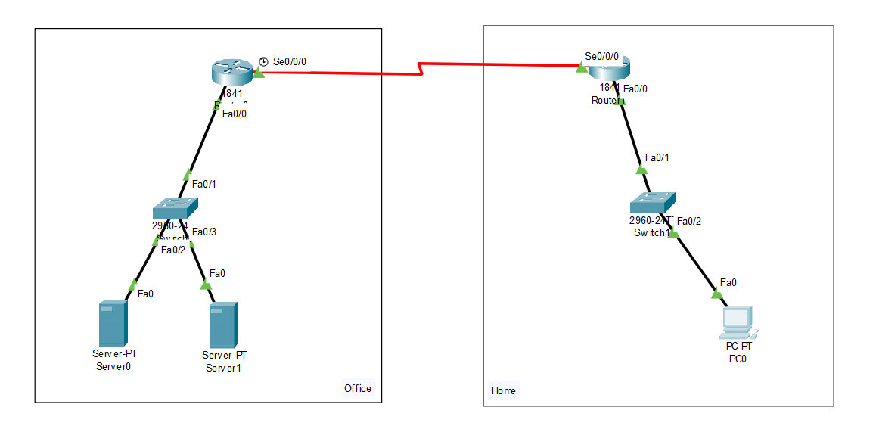

**The Office**

The left part of the above figure is the representation of an office.

**Components**

Server0 – Contains the main website which is available to the public which can be access by everyone.

Server1 – Contains the Admin files that can only be accessed by authorized employees of the company.

Switch – Splits connection to both the servers.

Router – Connects the servers to the internet.

**Home**

The right part of the above figure is the representation of an employee’s home.

**Components**

PC0 – The employee’s work PC.

Switch – Forwards connection to the PC.

Router – Connects the PC to the internet.

**IMPLEMENTATION**

**The Office**

**Router Configuration**

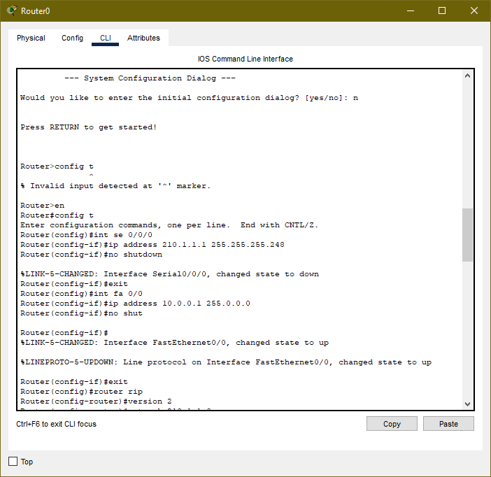

Assigning IP address to Serial and Fast Ethernet Connections

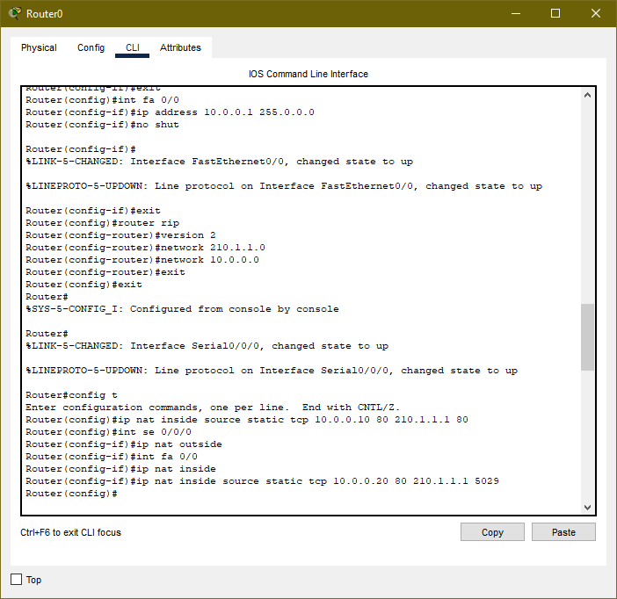

Routing using RIP V2 and Configuring Port Forwarding

**Server Configuration**

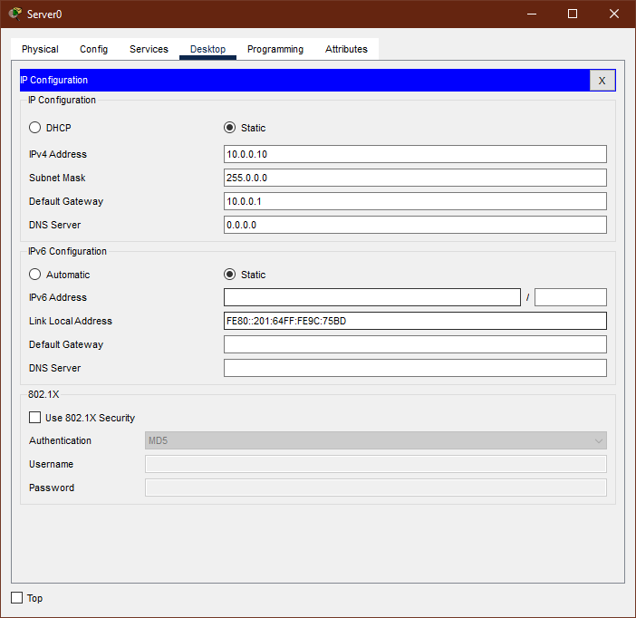

Server with Main Website (Port 80)

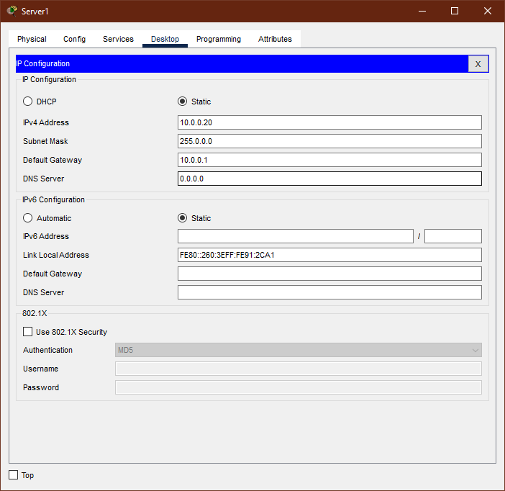

Server with Admin files (Port 5029)

**Home**

**Router Configuration**

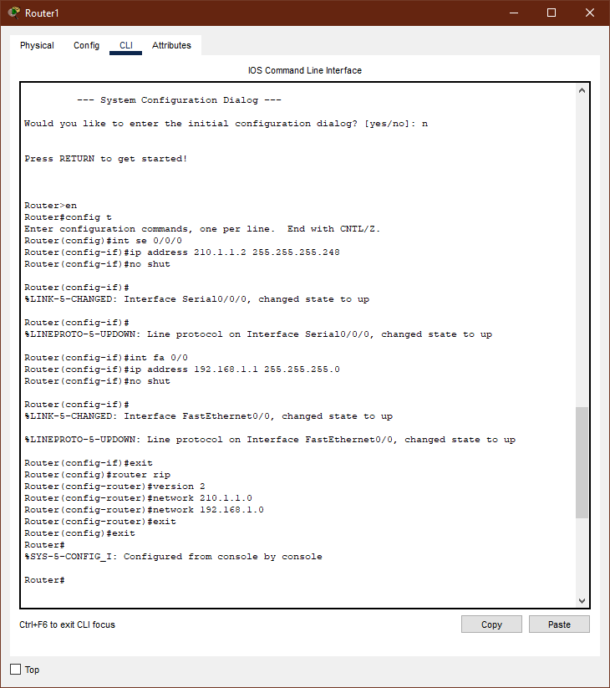

Routing using RIP V2

**PC Configuration**

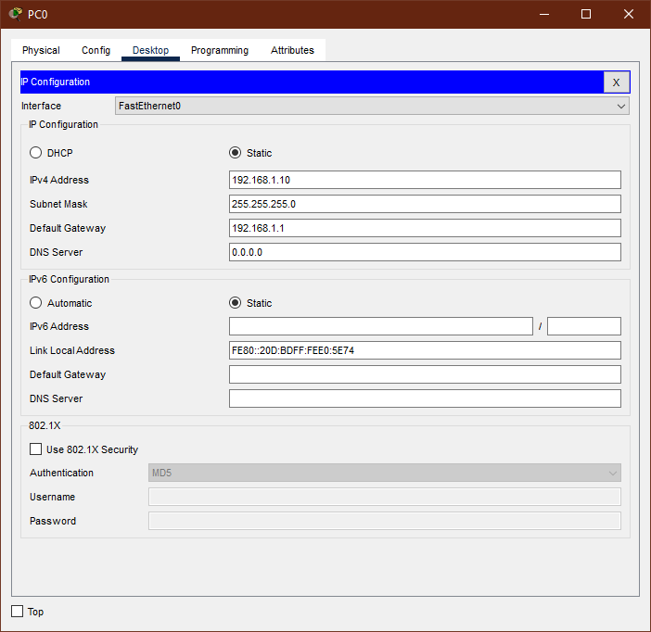

**Configured PC with Private IP**

**EXPERIMENT RESULTS & ANALYSIS**

**Results**

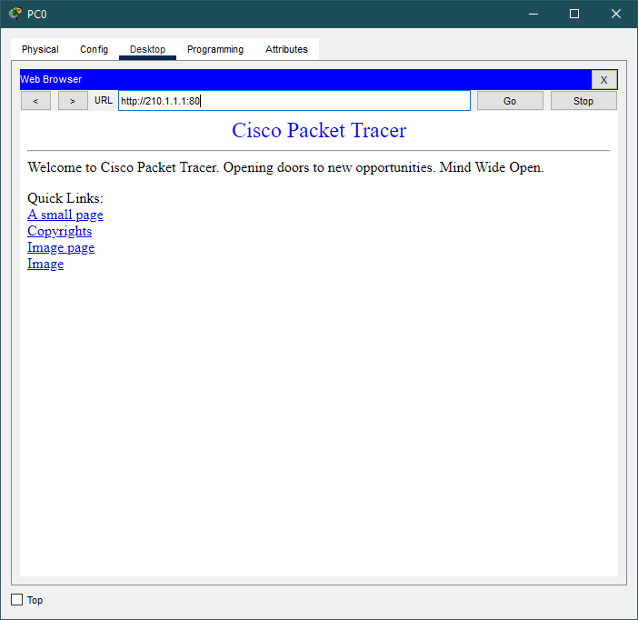

Main Webpage is displayed when the public IP is entered without any port specified. (Or Port 80).

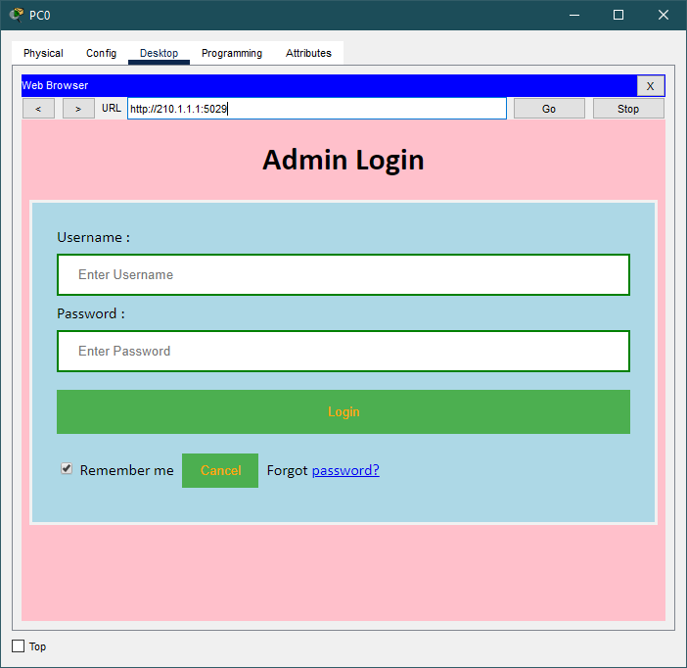

When the public IP with port 5029 is entered into the browser, the request is forwarded to Server0 containing the admin files by the router. Thus, the login page is displayed.

**Result Analysis**

**Router0 Configuration**

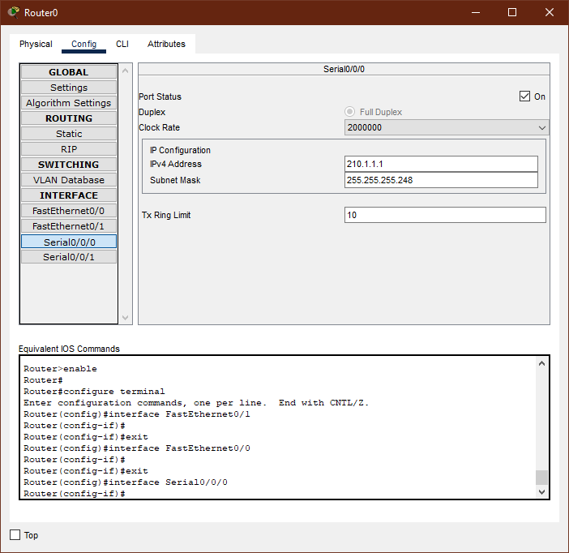

Set serial connection using CLI commands

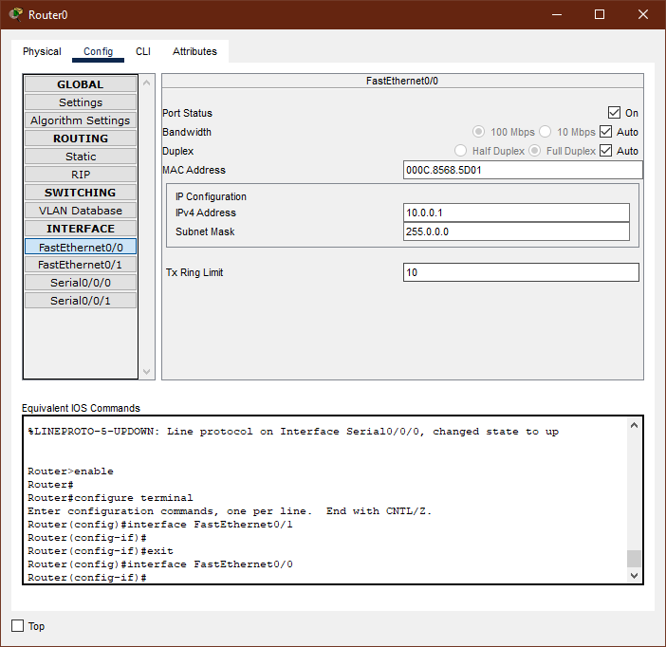

Configured Fast Ethernet using CLI Commands

**Router1 Configuration**

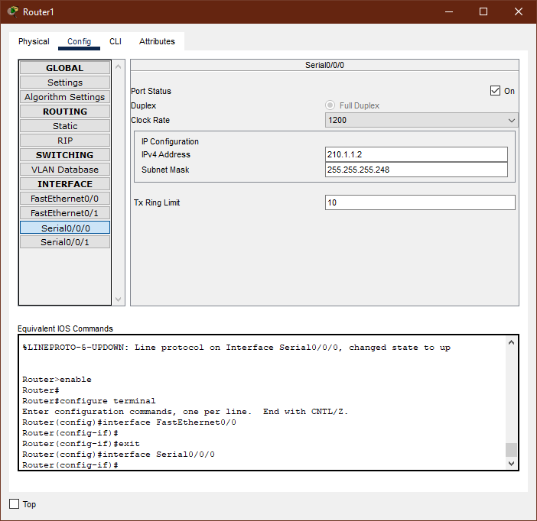

Set serial connection using CLI commands



Configured Fast Ethernet using CLI Commands

**Conclusion**

The simulation of connection between the workspace and home, and the implementation of port forwarding is completed.